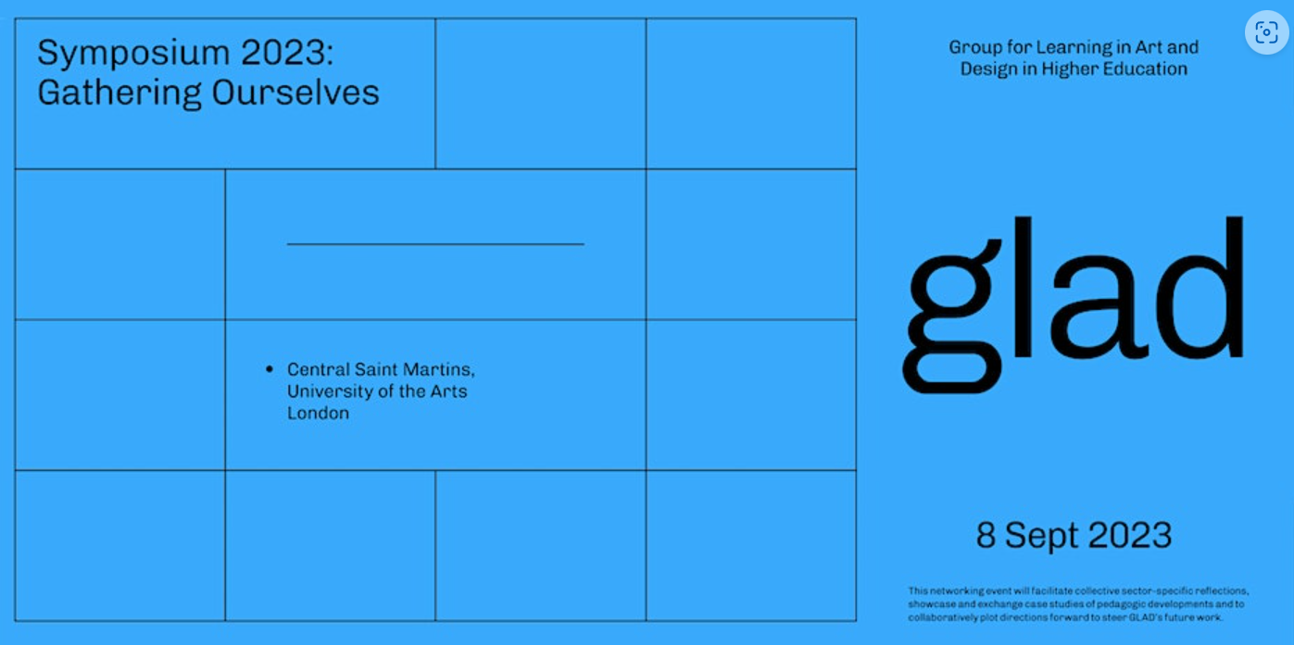

Symposium2023

Gathering Ourselves

Further to your acceptance for the Symposium 2023 “Gathering Ourselves” we are offering you the opportunity to submit either a paper or poster (with audio) for a Late summer/Early Autumn 2024 Special Edition with the on-line journal “Innovative Practice in Higher Education” - (IPiHE) based on the abstract submitted for the festival. Please find submission guidelines below, the deadline for submission is 14th Dec 2023 and submissions should be sent to GLADPubConf@hotmail.com for consideration. The Special Edition will be double reviewed and successful papers and posters will be notified of their acceptance by 31st Jan 2024.

To support colleagues that might value some “thinking time” to work on developing their submission GLAD is supporting a virtual writing retreat 7th Nov 2023 (please save the date), more information will be provided at the Festival in Sep 2023.

Should you require further details please contact GLADPubConf@hotmail.com
or e.j.power@salford.ac.uk.

Please visit GLAD website for submission guidelines https://www.gladhe.com/home/symposium2023 (also enclosed).

----------------------------

